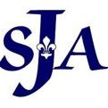
230 South Law Street
St. Joan of Arc School
Aberdeen, Maryland, 21001

Phone (410)272-1387
Grounded in Faith, Focused on the Future

Fax (410)272-1959
school@stjoanarc.org

January 29, 2018
Dear Families:
I am pleased to share with you that as of November 2017, St. Joan of Arc Prekindergarten program has achieved at the highest level with a Maryland EXCELS quality rating 5 by the Maryland State Department of Education (MSDE). Maryland EXCELS is the state’s Quality Rating and Improvement System that awards ratings to child care, private, and public prekindergarten programs. Programs participating in Maryland EXCELS work to meet increasingly higher standards in key areas that have been identified nationally as contributing to quality programs for children and families.
Through a process of continuous quality improvement, programs like ours meet rigorous standards over and above those required by State licensing regulations and public school requirements. The Maryland EXCELS standards include Licensing and Compliance, Staffing and Professional Development, Rating Scales and Accreditation, Developmentally Appropriate Learning and Practice and Administrative Policies and Practices.
St. Joan of Arc Catholic School’s mission as a faith community of educators, learners, and families is to use God's gifts to develop 21st Century skills of innovation, collaboration, problem-solving, and reasoning to enrich the global society.
St. Joan of Arc Catholic School’s vision is to create a vibrant 21st Century learning environment that infuses Catholic identity into every aspect of a curriculum focused on Science, Technology, Engineering, and Math (STEM). We accomplish this at every level, beginning with PreKindergarten.
I am pleased that you have chosen our program for your child and I invite you to see how choosing high quality care and education can make a difference by visiting the Maryland EXCELS website at www.MarylandExcels.org. There you can view our program’s rating and learn about the importance of choosing quality early education programs for your child’s success in school and in life.

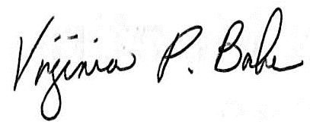
Mrs. Virginia P. Bahr, Principal
St. Joan of Arc School
230 South Law Street
Aberdeen, Maryland 21001
Phone (410)272-1387
vbahr@stjoanarc.org
