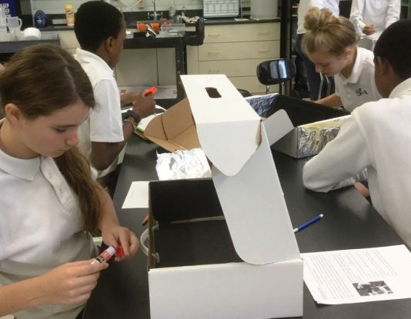
8th grade students recently worked with kindergarten to complete an engineering design project. They learned the basics of solar energy and thermodynamics. Then, they designed and built simple solar ovens out of boxes by following the engineering design process.
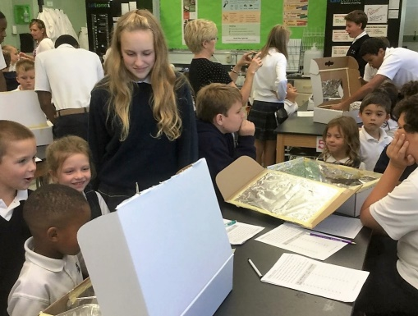
After the ovens were built, students cooked s’mores and measured the temperature inside their ovens at set time intervals to determine whether or not the position of the s’mores within the box affected the cooking rate.
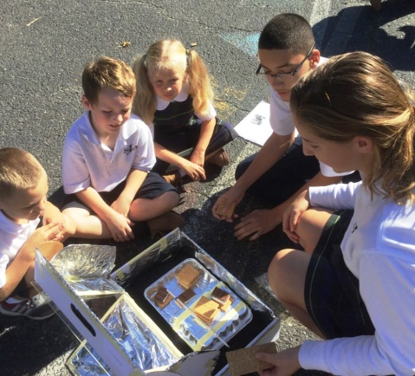
Kindergarten students got to share the s’mores with the 8th grade students. 8th graders then graphed temperature vs. time and wrote summaries of their experience.

